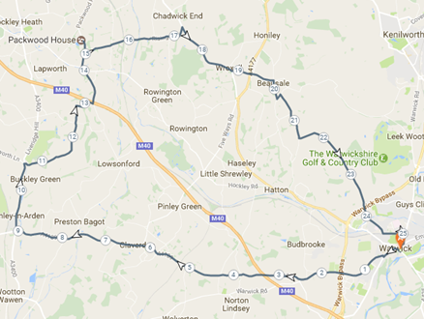*** Sunday 12th March - Club Cycle ***

The **online map** for the next cycle:

https://www.plotaroute.com/map/368246

**Meet 9:30am** for **10am departure**.

The route is about **25.5 miles** so I imagine should take **2 hours** (an additional 30 minutes for tea break).

If people want to split into slower/faster groups that’s alright.

Here is a brief **route description**:

Head west out of Warwick; past the **Racecourse** taking signs on the A4189 for **Claverdon**/**Henley-in-Arden**. At Henley, head north on the A3400 towards **Hockley Heath**. Just before the “Best Western Henley” take a right turn towards Copt Green. At **Copt Green** takes signs for **Packwood House**, where we’ll hopefully stop for tea.

After the tea break, take signs for **Chadwick End**, before dipping southwards to **Wroxall**. Having passed through Wroxall, pass over the A4177 towards **Beausale**. Then wend your way south, through **Wedgnock** and enter Warwick from the north. Head through Warwick, past the train station back to WBC.

**Any questions**, feel free to email me at [jonnymessling@gmail.com](mailto:jonnymessling@gmail.com)

Jonny Messling